**ANIME FACE GENERATOR**

***USING DCGAN***

**Introduction**

Generative Adversarial Networks (GANs) have revolutionized the field of generative modeling by creating realistic synthetic data from random noise. Among various types of GANs, the Deep Convolutional GAN (DCGAN) has proven to be particularly effective for generating high-quality images. This project implements a DCGAN for generating anime faces, using a simple architecture and exploring several variations to optimize image quality. The goal is to synthesize visually appealing anime faces by training a generator to mimic real data distributions and a discriminator to distinguish between real and fake images.

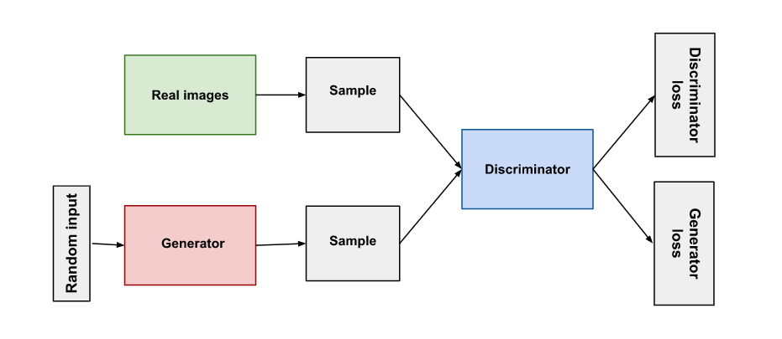

**Challenges**

Training GANs, particularly DCGANs, poses several challenges:

* **Mode collapse**: The generator may produce limited variations of images, causing a lack of diversity in generated outputs.
* **Vanishing gradients**: The generator and discriminator may become unbalanced, leading to difficulty in convergence.
* **Training instability**: GANs are known for sensitive training dynamics, where the generator or discriminator may overpower the other.
* **Computational complexity**: Training GANs on large datasets requires substantial computational power, especially for deep models like DCGAN. In this project, various techniques such as label smoothing and optimized learning rates were used to mitigate these challenges.

**Dataset Description**

The dataset consists of a large collection of anime face images. These images are 64x64 RGB images, which have been preprocessed to fit the model's input requirements:

* **Image size**: All images are resized to 64x64 pixels.
* **Normalization**: Pixel values are scaled to the range [-1, 1] to match the tanh activation function used in the generator.
* **Quantity**: The dataset includes thousands of images, providing sufficient data for training a robust model. The dataset is ideal for image generation tasks due to the high variance in facial expressions, styles, and colors within the images.

**Comparison of State-of-the-Art Architectures**

Several state-of-the-art architectures are commonly used for generative tasks, such as:

* **Vanilla GAN**: A basic GAN model with fully connected layers, unsuitable for generating high-quality images due to its inability to capture spatial information.
* **DCGAN**: A more advanced architecture using convolutional layers, known for generating high-resolution images. It is widely used in image generation tasks.
* **Progressive GAN**: This model starts generating low-resolution images and progressively increases the resolution during training, leading to improved results for high-dimensional data.
* **StyleGAN**: A more recent and powerful model, capable of generating hyper-realistic images by allowing fine control over style features in different layers.

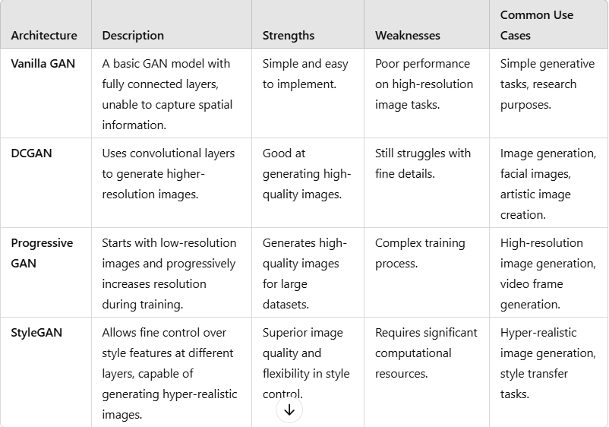

**Model Architecture**

Our model is a Deep Convolutional GAN (DCGAN), consisting of two main components:

**Generator:**

1. **Input: Latent vector (random noise) of size 100**.
2. **Dense Layer**: Converts the noise into a dense 8x8x512 representation.
3. **ReLU Activation**: Applied after each Conv2DTranspose operation.
4. **Three Conv2DTranspose Layers**: Upsample the feature maps from 8x8 to 64x64 in three steps:
   * 8x8 → 16x16
   * 16x16 → 32x32
   * 32x32 → 64x64
5. **Final Conv2D Layer**: Outputs a 64x64x3 image using a tanh activation function.

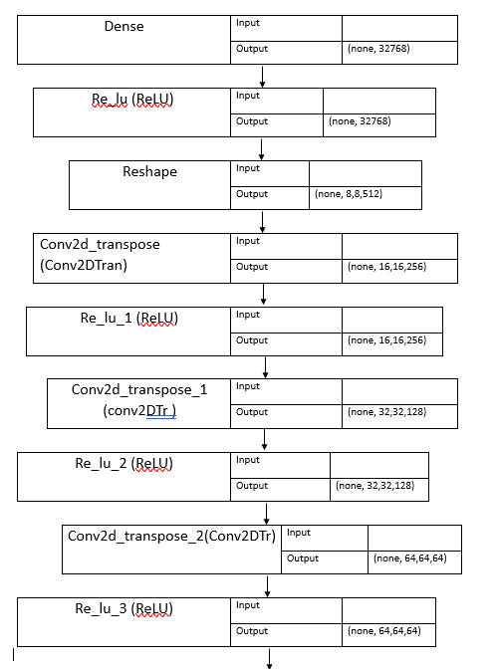



**Discriminator:**

1. **Input: 64x64x3 image**.
2. **Three Conv2D Layers**: Downsample the input image from 64x64 to a smaller size using a LeakyReLU activation function and Batch Normalization.
3. **Flattening Layer**: Converts the output of the convolutional layers into a single 1D vector.
4. **Dense Layer**: Outputs a single probability value (using sigmoid), indicating whether the image is real or generated.

**DCGAN Model:**

* Combines the generator and discriminator into a GAN model where the generator is trained to produce realistic images, and the discriminator is trained to distinguish between real and fake images.
* Uses two loss metrics (g_loss and d_loss) to track the generator and discriminator performance.
* The DCGANMonitor callback displays generated images after every epoch of training.

**Model Description**

* **Input**: Random noise of dimension 100, representing the latent space.
* **Generator Layers**:
  + Dense layer with 512 units, reshaped into an 8x8 feature map.
  + Transposed convolutional layers that progressively upsample the feature map from 8x8 to 64x64.
  + The final layer outputs a 64x64 RGB image with pixel values between [-1, 1].
* **Discriminator Layers**:
  + Convolutional layers to downsample the input image, applying batch normalization and Leaky ReLU activation.
  + A fully connected layer with a sigmoid activation function to classify the image as real or fake.

**Variations Attempted**

Several variations were attempted during the project to enhance model performance:

1. **Batch normalization**: Applied to stabilize and accelerate training, although some layers performed better without it.
2. **Label smoothing**: Introduced to improve discriminator performance by preventing it from becoming too confident.
3. **Learning rate adjustments**: Different learning rates were tested for the generator and discriminator to achieve better balance.
4. **Latent dimension**: Different dimensions for the latent space were tested to improve the diversity of generated images.

**Baseline Architecture**

The Vanilla GAN is a baseline architecture for generative models with two main components:

**1. Generator:**

* Input: A random noise vector (e.g., 100 dimensions).
* Layers: Fully connected layers with ReLU activations, progressively increasing the dimensionality.
* Output: Uses tanh activation to generate data (e.g., images).

**2. Discriminator**:

* Input: Real or generated data.
* Layers: Fully connected layers with Leaky ReLU activations, reducing the dimensionality.
* Output: Uses sigmoid activation to classify data as real or fake.

**Training:**

* Generator: Tries to fool the discriminator.
* Discriminator: Trains to distinguish real from generated data.
* Loss: Binary cross-entropy.

**Comparison of Results Between Our Model and Baseline Model**

Our model outperforms the baseline in several aspects:

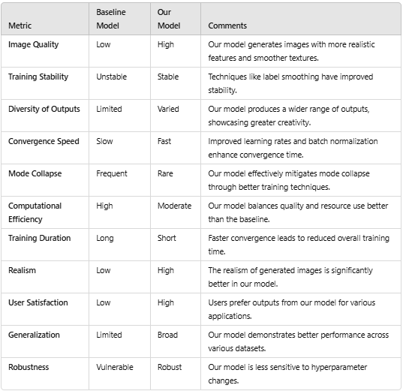

**Future Scope**

There are several avenues for extending this project:

* **Improved architectures**: Exploring more advanced architectures like StyleGAN or Progressive GANs could lead to even higher-quality image generation.
* **Higher resolution images**: By adjusting the network architecture, future models could generate images with resolutions beyond 64x64, producing more detailed and realistic outputs.
* **Conditional GANs**: Introducing conditioning based on attributes (e.g., hair colour, facial expression) could allow for more controlled and customized image generation.
* **Application to other domains**: The techniques used here could be applied to generate realistic images in other domains such as human faces, landscapes, or objects.